Map

Objective:

To create an interactive map for users to find buildings such as dorms, colleges, libraries and University buildings as well as parking lots and other campus amenities.

Requirements:

Create interactive map

Add all Howard University buildings to the map

Create categories for map

Allow images for each map location

Create pages for each map location

            With detailed map

            Ability to get directions from current address to map location

            Ability to see multiple views (terrain, road, and satellite)

Allow checkbox categorization for each category

            With category search

Allow complete map search

            With listing name

            With listing place

Allow pin popup for listings

            Ability to add address to popup

Make map wide and full page width

Map whole map mobile friendly

Create categories for parking for students, faculty and staff

Design

Research other university maps

Widebox map

(wide feature now embedded into code) 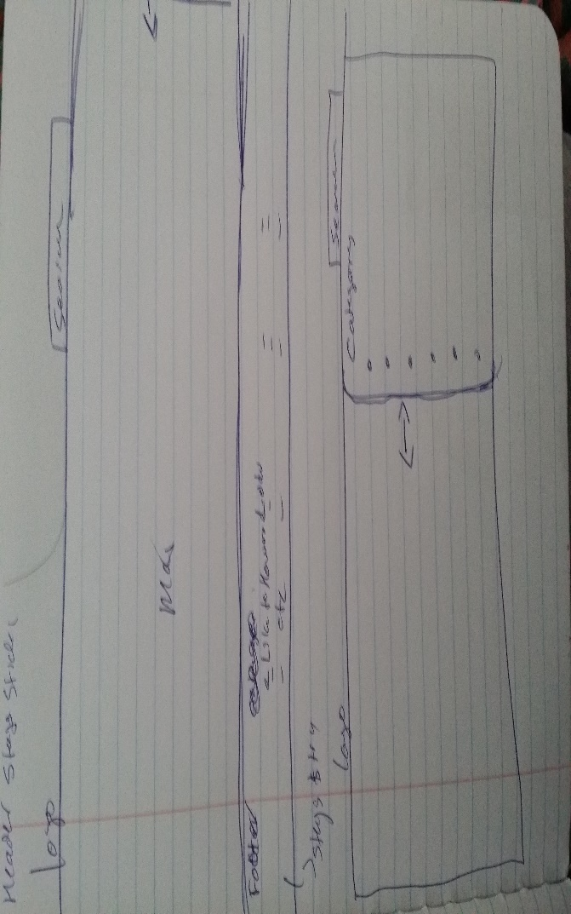

Top navigation search bar for easy accessibility

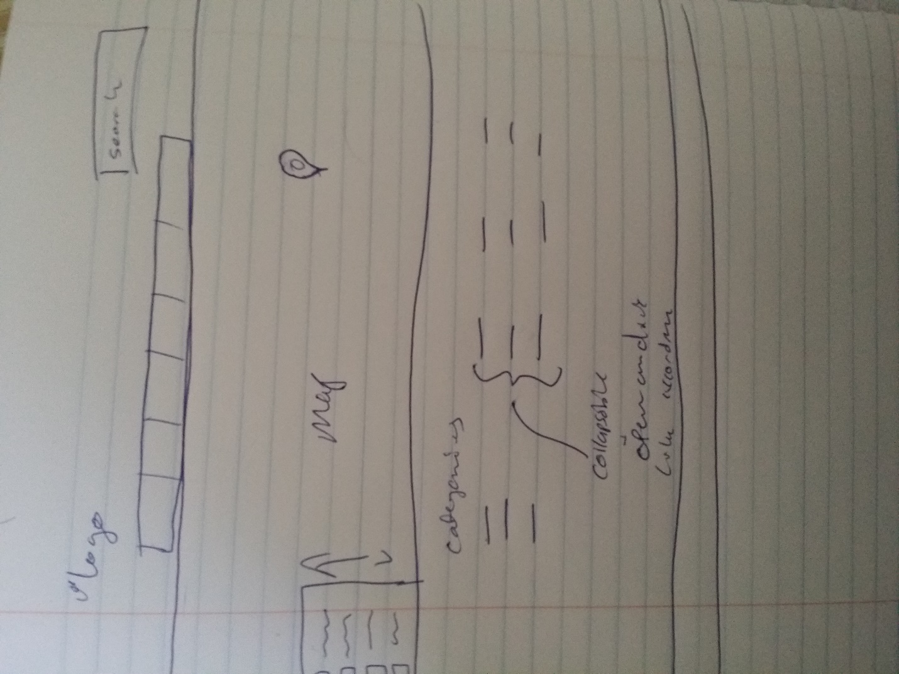

**Global layout** –

* + **Default** – this is the default and al content appears on left side and sidebars show up on the right .
  + **Two columns, Left** – typically same as default layout with almost equal two columns
  + **Two columns, Right** – opposite of default layout.
  + **Full width** –no sidebars only content shown.

Development:

Part 1

Understand the scope of google map API

-adding locations to google map

-using googls map api on websites

Adding custom search to google maps

-using googles location based distance api for directions

Part 2

Contacting other schools and learning how they made their map

The schools that use google api

* Get feed back

Understood that all maps were custom designed theme

Using just google map and adding locations any user can add location to map or edit locations etc.

Custom design for map🡪 with google map api embedded 🡪 without places and location services

Part 3

Finding a web solution

HTML Design, CSS and jquery Design 🡪 very time consuming.

Installing google api,

slow map loading

Part 4

Wordpress solution

Find already existing solutions for map designs using wordpress

Solutions found

* Explorable
* Mapifyit (plugin not a theme)
* Glocal
* Geo Theme ( complete wordpress framework)
* Geo places (also complete frame work)

Drawbacks

Using frameworks allows difficulty for change

Some embedded functionality is hard to remove

-removed code may effect existing code

Solution requires MySQL without it it cant function

Difficulty in cache process and updating

Always requires CPanel for functioning

* Additional 1 gb ram usage when when not used

Good points

-wordpress allows for easy posts

- converting locations into posts allows for easy categorization

- post are not pages but can be made to function as such

Map solution already exists, adding custom css for changes

Easy to make responsive for designs

Allows out of the box user accounts, and basic settings

Installation

* Create CPanel account on server ( instructions can be found online)
* Create new database, name it
* Create new user, add password
* Add new user to the new database
* [www.wordpress.org](http://www.wordpress.org),, download wordpres
* Extract wordpress,
* Login to cpanel, go to file manager
* Public html 🡪 upload zip file for wordpress here
* Extract after upload
* Move all files to main public_html
* Go to url in browser create config file
* Add in dastabase details and install

Installing of theme

* Once wordpress is installed click apperances🡪 theme
* Upload theme
* Find theme zip file on computer( make sure its only wordpress installation and not all files included as install will fail)
* Once upload is complete
* Do basic customization
* Go to apperances 🡪 customize and change site logo, assign menu , and footer

The map functionality although built into the theme it doenst display out of box

* Maps are widgets
* Widgets can be assigned anyplace op a page
* Widgets only use the specific with of the page or assigned width of widget

For example,

new TWTR.Widget({  
version: 2,  
type: 'profile',  
rpp: 25,  
interval: 6000,  
width: 171,  
height: 600,  
theme: {  
shell: {  
background: '#333333',  
color: '#ffffff'  
},  
tweets: {  
background: '#000000',  
color: '#ffffff',  
links: '#4aed05'  
}  
},  
features: {  
scrollbar: true,  
loop: false,  
live: false,  
hashtags: true,  
timestamp: true,  
avatars: false,  
behavior: 'all'  
}  
}).render().setUser('informedlife').start();

Although widths are assigned in this widget above , one can easily change the dimensions, but changing from widgets main source send is a bad idea

* Resulted in broken functionality for map and categories
* Adding custom.css resulted in override css code for all widgets and theme including menu

Current custom css code already applied in source of theme as mistake

.header_left {

width: 200px;

}

.dcjq-accordion {

position: fixed;

width: 160px;

}

@media all and (min-width:768px) and (max-width:1000px) {

.dcjq-accordion {

width: 15%;

}

}

@media all and (max-width:767px) {

.dcjq-accordion {

position:static;

width: 100%;

}

}

.vc_responsive .vc-no-padding .vc_span4 {

margin-left: 0;

width: 328px;

}

.header.layout_2 .sf-menu li:hover a,

.header.layout_2 .sf-menu li.current-menu-item a,

.header.layout_2 .sf-menu li.current-menu-ancestor a {

color: #fff !important;

}

.header.layout_2 .sf-menu li:hover ul a {

color: #004085 !important;

}

#dc__widget-2-item ul .current-menu-item a {

background: #05477C;

}

#dc__widget-3-item ul .current-menu-item a {

background: #05477C;

}

.vc_progress_bar .vc_single_bar.bar_black .vc_label{

color: #000000;

}

.comment_box {

display: none;

}

This code should have been added to custom.css file included making widgetzed map responsive

Due to this mistake , many of themes functionality have broken at times till this version

Adding functionality to map

1. Adding pins